### **28. OSPF: Part 3 (IGP: Link State)**

#### **Loopback Interfaces**

* A **Loopback Interface** is a virtual interface in the router.
* It is **always UP/UP** unless manually shut down.
* It is not dependent on a physical interface, making it a consistent IP address for identifying/reaching the router.

#### **OSPF Network Types**

The **OSPF Network Type** refers to the connection type between OSPF neighbors (e.g., Ethernet).  
 There are **three main OSPF network types**:

1. **Broadcast**:
   * Default enabled on **Ethernet** and **FDDI** interfaces.
2. **Point-to-Point**:
   * Default enabled on **PPP** and **HDLC** interfaces.
3. **Non-Broadcast**:
   * Default enabled on **Frame Relay** and **X.25** interfaces.

💡 **Note**: CCNA focuses on **Broadcast** and **Point-to-Point** types.

#### **OSPF Broadcast Network Type**

* Default on **Ethernet** and **FDDI** interfaces.
* Routers dynamically discover neighbors by sending/listening for OSPF "Hello" messages via multicast address **224.0.0.5**.
* A **Designated Router (DR)** and **Backup Designated Router (BDR)** are elected for each subnet.
* Non-DR/BDR routers become **DROthers**.

##### **DR/BDR Election Order of Priority**

1. Highest OSPF **Interface Priority**.
2. Highest OSPF **Router ID**.

💡 **Default Interface Priority** is 1 for all interfaces.

To change the OSPF interface priority:  
 R2(config-if)# ip ospf priority <priority number>

* **Priority = 0**: The router cannot become the DR/BDR.

💡 **DR/BDR Election is non-preemptive**: Once elected, roles remain until OSPF resets or an interface fails/shuts down.

💡 **Full Adjacency Rules**:

* Only the DR/BDR form full adjacency with all routers in the subnet.
* DROthers form full adjacency only with the DR/BDR, neighbor state with DROthers will be 2-way to reduce LSA flooding.

Messages to DR/BDR: Multicast to **224.0.0.6**.

#### **OSPF Point-to-Point Network Type**

* Enabled by default on **Serial Interfaces** using **PPP** and **HDLC** encapsulations.
* Routers discover neighbors using **Hello** messages (multicast **224.0.0.5**).
* **No DR/BDR election** is required because the connection is directly between two routers.

#### **Serial Interfaces**

* **DCE/DTE** Roles:
  + One side of a serial connection acts as **DCE** (Data Communications Equipment).
  + The other side acts as **DTE** (Data Terminal Equipment).

**DCE needs to specify the Clock Rate:**

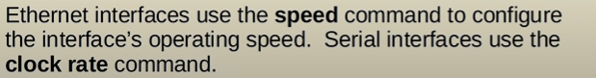  
 R1(config-if)# clock rate <bits-per-second>

* Default encapsulation: **HDLC**.

Change encapsulation to PPP:  
 R1(config-if)# encapsulation ppp

To identify DCE/DTE:  
 R1# show controllers <interface-id>

💡 Note: Encapsulation must match on both ends of a serial connection or the interface will go down.

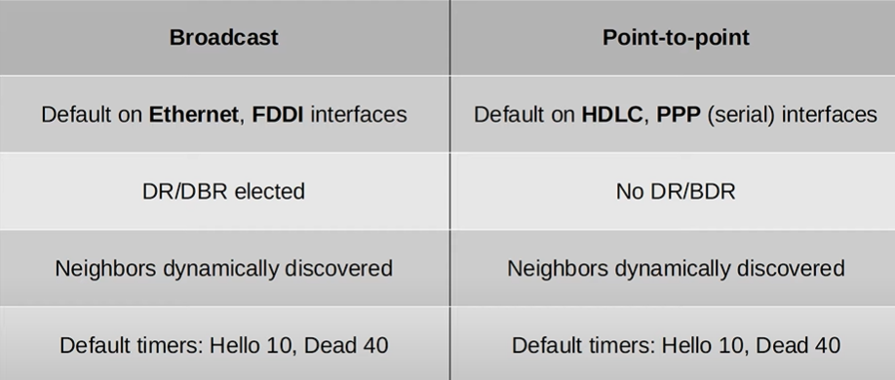

#### **OSPF Neighbor/Adjacency Requirements**

1. **Area Number** must match.
2. Interfaces must be in the **same subnet**.
3. OSPF process must not be **shutdown**.
4. **Router ID** must be unique.
5. **Hello/Dead Timers** must match.
6. **Authentication Settings** must match.
7. **IP MTU Settings** must match (for proper operation). -MTU stands for Maximum Transmission Unit, and it's the largest packet size that can be transmitted over a network.
8. **OSPF Network Type** must match.

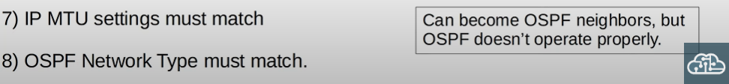

#### 

#### 

#### 

#### 

#### 

#### 

#### 

#### **OSPF LSA Types**

The OSPF Link-State Database (LSDB) comprises LSAs. Key types for CCNA:

1. **Type 1 (Router LSA)**:
   * Generated by every OSPF router.
   * Identifies the router via its **Router ID**.
   * Lists networks attached to the router’s OSPF-enabled interfaces.
2. **Type 2 (Network LSA)**:
   * Generated by the **DR** of each multi-access network.
   * Lists routers attached to the network.
3. **Type 5 (AS-External LSA)**:
   * Generated by **ASBRs** to describe routes to destinations outside the OSPF domain.